**Ayesha Zubair**

**52916**

**Lab 12**

**Tasks**

Task 1:

**Verify that CLA sets the accumulator (AC) to zero.**

INP

OUT

CLA

OUT

HALT

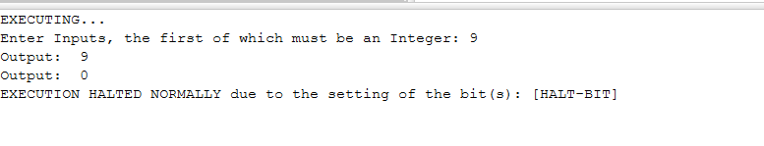

Task 2:

**Verify that CMA inverts all bits in the AC.**

INP

CMA

OUT

HALT

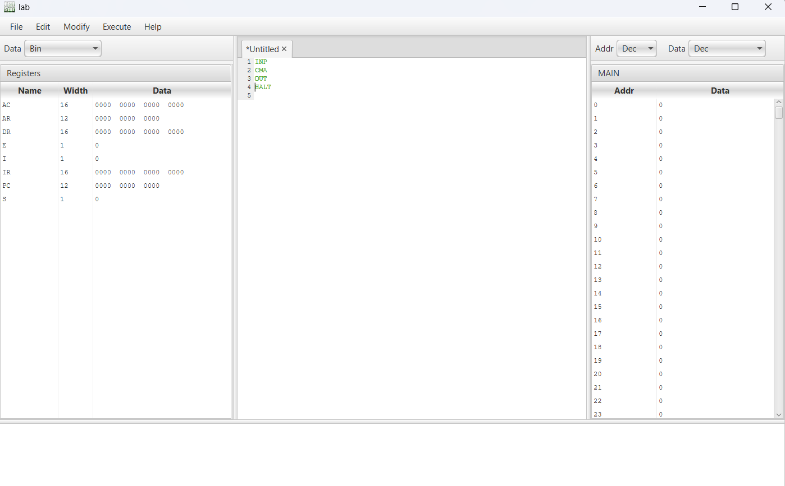

**Output:**

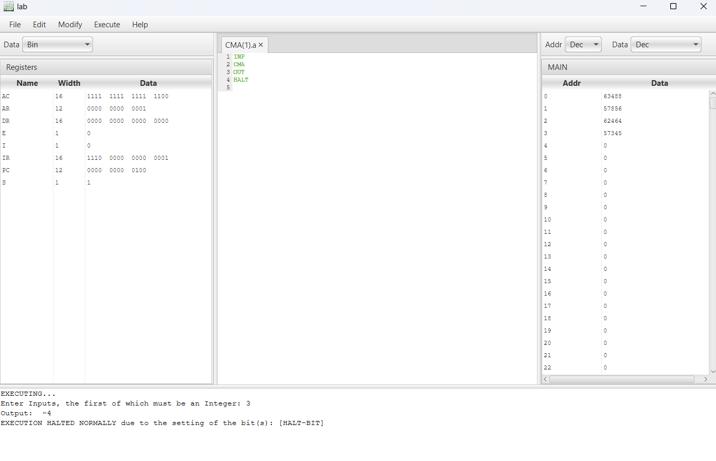

**Task 3:**

INP

INC

OUT

HALT

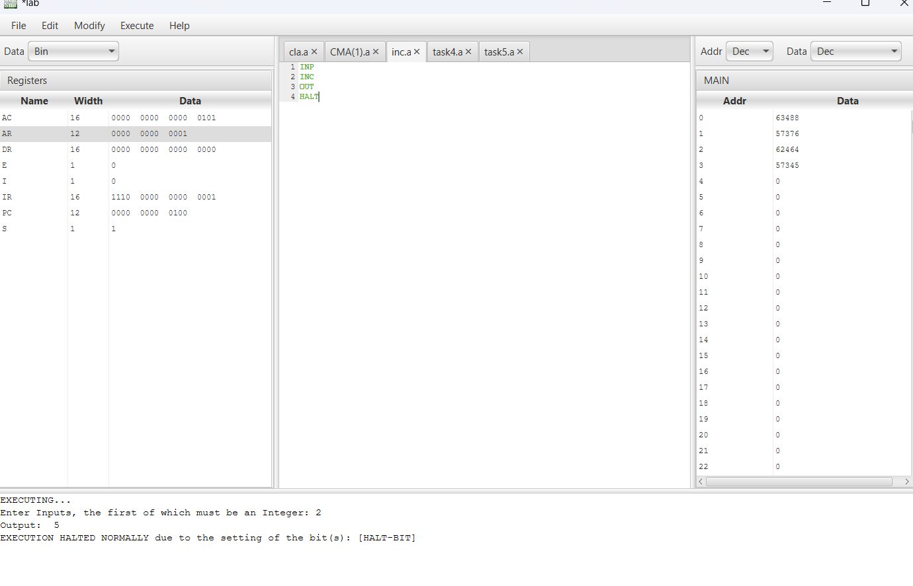

Task 4:

**Skip next instruction only if AC is positive.**

INP

SPA

OUT

HALT

Output:

On entering positive number:

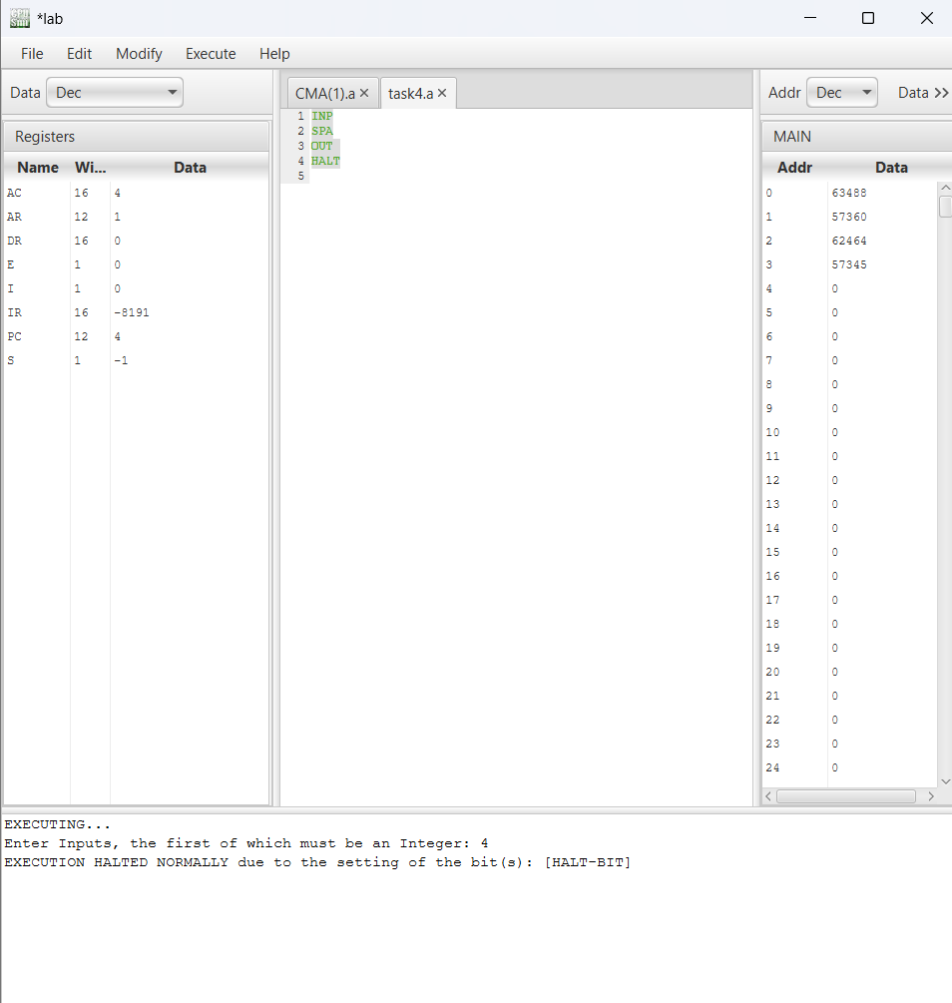

On entering negative number:

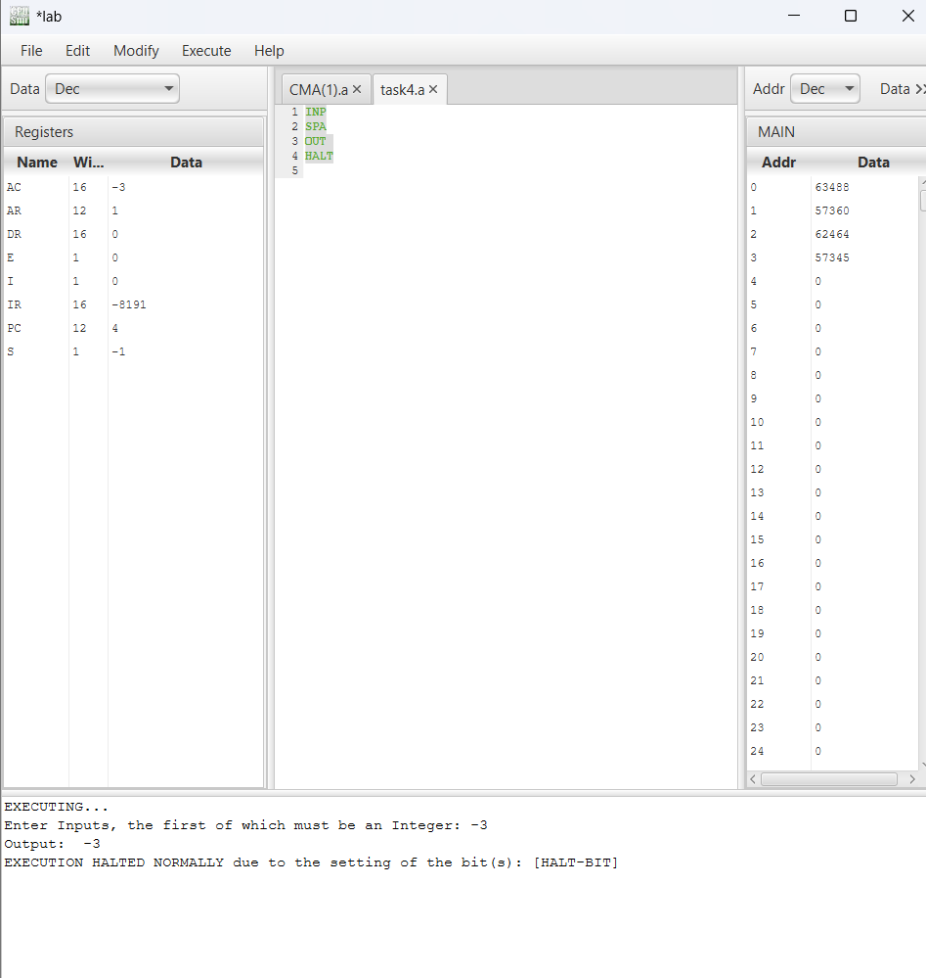

Task 5:

**Skip next instruction only if AC is negative.**

INP

SNA

OUT

HALT

Output:

On entering negative number:

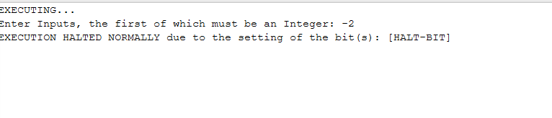

On entering positive number:

